Table of Contents
Phase 1 - SQL 2
Phase 2 - Cosmos DB 12
Phase 3 - Datalake 18
Phase 4 – Raw DB 21

Anonymization Process
The anonymization of member details was being processed in four different phases.

Phase 1 - SQL Portion: DATA Anonymization for SCENE Members
PS: To execute and save the changes for the below stored procedure, you require write access on the:
Database server: sceneplus-prod-synapze-sqlmi-p.public.5756d74dd563.database.windows.net, 3342
Database: synapze-sceneplus

Stored Procedure name: [dbo].[p_core_customer_delete]

The purpose of the above stored procedure is to anonymize the personal identity data of a closed member's account within the system as we don't hard delete from our database.

NB: This stored procedure is strictly for Scene members.

PS: ALL three below listed criteria has to be met by the account intended to be anonymized, BEFORE, executing the above store procedure for the intended account number in Production Else, the anonymization will fail.

1. The account SHOULD NOT be linked to a BNS account.
2. The account has to be closed.
3. The account SHOULD BE Unsubscribed for SMS.

--------------------------------------------------
Sample Jira ticket ask:
https://jira.bondbrandloyalty.com/browse/SDGRQ-6147
-------------------------------------------------------------------------------------------------------------------
Once, the above check points are confirmed, BEFORE the Anonymization process execution, please create an ivanti ticket for the approval of the process.
Sample Ivanti: https://bondbl-amc.ivanticloud.com/login.aspx?Scope=ObjectWorkspace&CommandId=Search&ObjectType=Change%23&CommandData=RecId%2C%3D%2C0%2C177740DF378B4EBABB805B2CF52C4609%2Cstring%2CAND%2C%7C

----------
Scripts (Two) to run before and after anonymization execution:

STEP 1
//Confirms the status of a customer before Anonymization:
SELECT C.FirstName, C.LastName, a.AccountNumber, lower(a.UniqueID) as 'Account Unique ID', a.SuspendedFlag, a.DeleteFlag, a.DeleteDate, ca.DeleteDate, ca.DeleteFlag, c.CustomerID, lower(c.UniqueID) as 'Customer UniqueID',
c.EnrollmentStatusID, es.Name, ca.CustomerAccountID, a.AccountID FROM
[synapze-sceneplus].[Core].[Customer] as c,
[synapze-sceneplus].[Core].[CustomerAccount] as ca,
[synapze-sceneplus].[Core].[Account] as a,
[synapze-sceneplus].[Lookup].[EnrollmentStatus] as es
where c.CustomerID=ca.CustomerID and ca.AccountID= a.AccountID and c.EnrollmentStatusID = es.EnrollmentStatusID and a.AccountNumber = '[Insert Card/Account Number]' //Sample data - 6046463894591323

RESULT BEFORE ANONYMIZATION:

//Confirms the member's communication preference AKA not opted in for SMS:
SELECT cmp.CustomerID, cmp.PreferenceID, lcp.Code as 'Communication Preference', cmp.StatusID, lcps.Code as 'Status' FROM
[synapze-sceneplus].[Communication].[CustomerCommunicationPreference] as cmp,
[synapze-sceneplus].[Lookup].[CommunicationPreference] as lcp,
[synapze-sceneplus].[Lookup].[CommunicationPreferenceStatus] as lcps
WHERE cmp.PreferenceID = lcp.PreferenceID and cmp.statusID = lcps.PreferenceStatusID and cmp.CustomerID = '[Insert CustomerID]' //Sample data - 46469483

RESULT BEFORE ANONYMIZATION:
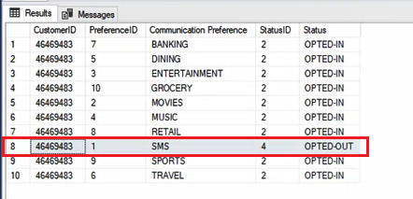
Added on 20250715:
Note: If in case the Communication Preference SMS was not OPTED-OUT and the account was already closed, we can manually update the following and use the attached script below for reference.

Update the values of statusID to 4 in the following tables
1. Communication.CustomerCommunicationPreference from 2 to 4 (OPTED-IN to OPTED-OUT)
2. Communication.SmsSubscriptionRequest from 3 to 4 (SUBSCRIBED to UNSUBSCRIBED)

<<14794 - Update CommunicationPreference StatusID to 4.sql>>

<<14794 - Update SMS Subscription Request to 4 .sql>>

STEP 2:
//Executing Anonymization in debug mode FIRST, to review the resulting messages to ensure all is well with the run:
EXEC [synapze-sceneplus].[dbo].[p_core_customer_delete] @card_number = '[Insert Card/Account Number]', @debug = 1

IDEAL MESSAGE RESPONSE:
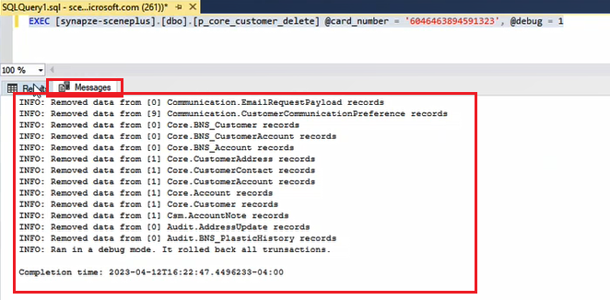

Over View of an IDEAL Result set:
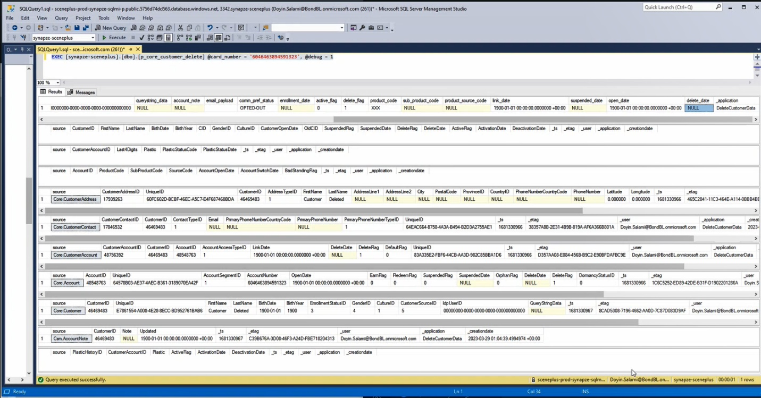

=========================================================================
Important things to consider if the Scene Account is previously linked to a BNS account.
Reference ticket: https://dev.azure.com/BondBL/Harmony/_workitems/edit/91410

The account that we want to anonymize might still have a CID number attached to it although Scotia Squad or someone from the CDS team confirmed that it has been delinked to the BNS account.
This is how it looks like in CSM
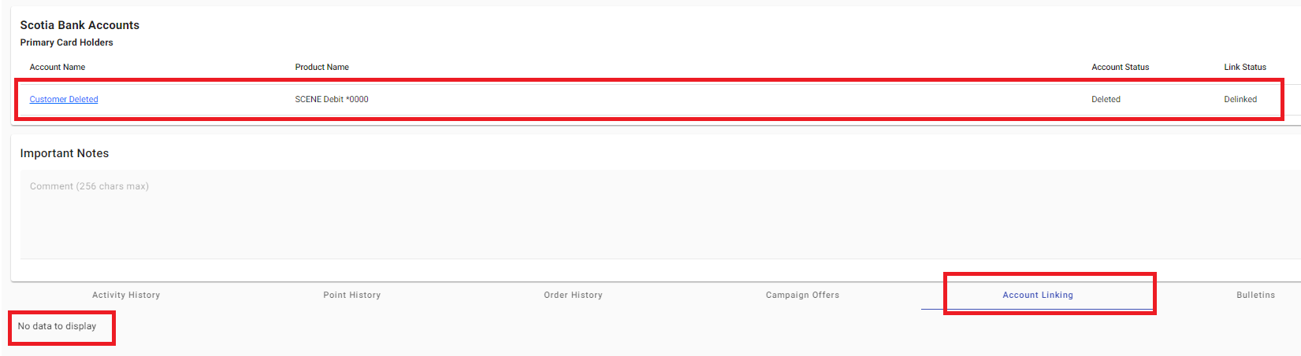

When you run the script in debug mode and you face the same error below, we need to update the account that has CID 0000000000000000 to something else, otherwise, the stored procedure will not work as one of its actions is to set the CID number of the account we want to anonymize to 0000000000000000.

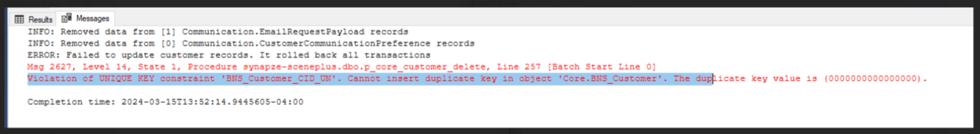

--to look for customer with CID as 0000000000000000
SELECT * FROM core.BNS_Customer WHERE CID = '0000000000000000'

--Use the customerID from the result of the above script to set the CID to something else instead of 0000000000000000.

BEGIN TRANSACTION

UPDATE Core.BNS_Customer
SET CID = '000000000000000Y' -- you might need to change this to something else too
WHERE CustomerID = 56436849

ROLLBACK TRANSACTION
--COMMIT TRANSACTION

Once you update the CID to something else, you should not have an issue in running the stored procedure in debug mode.
=========================================================================

STEP 3:
//Rollback (FYI: The above debug mode run, can also be considered a rollback) or Save Transaction Anonymization Execution
BEGIN TRANSACTION

EXEC [synapze-sceneplus].[dbo].[p_core_customer_delete] @card_number = '[Insert Card/Account Number]'

--ROLLBACK TRANSACTION
--COMMIT TRANSACTION

MESSAGE WHEN COMMITED:
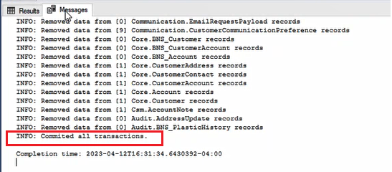

------------------------------------------
OPTIONAL:
---------------------------------------------
YOU CAN ADD THE BELOW CATCH BLOCK TO THE END OF THE SCRIPT ABOVE IN STEP 3 TO BY-PASS THE SELECT STATEMENT IN STEP 4 OR LEAVE OUT THE BELOW CATCH BLOCK AND EXECUTE STEP 4.
BEGIN CATCH
If @@TRANCOUNT > 0
ROLLBACK TRANSACTION
PRINT 'FAILED - ROLLED BACK'
Print Error_Message()
END CATCH

STEP 4:
//To confirm if there is any open transaction/s, because whenever you make an update in Production, sometimes something fails; transactions may remain open and create havoc. Run after executing the above step; the ideal result should be 0, else, it means something failed somewhere and you need to roll back and run the delete script again, or close the window, so the transaction and connection is closed and everything would be rolled back to end that session/transaction.

//Basically the below confirms everything is committed.
SELECT @@TRANCOUNT

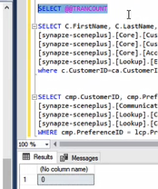

------------------------------------------------------------------------------------------------------------------

RESULT:
Successful Anonymization verification in SQL:
SCRIPT 1:
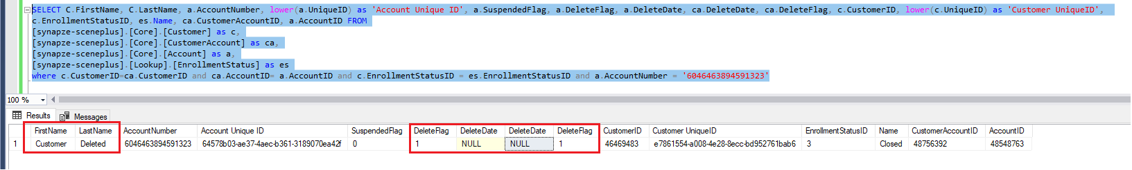

SCRIPT 2: (NOTICE ALL OTHER STATUS ARE ALSO 'OPTED-OUT')
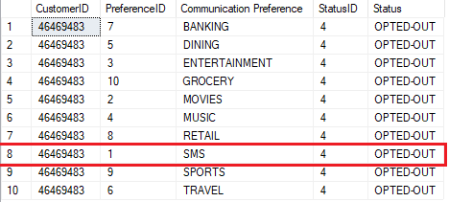

- The highlighted DeleteFlag and DeleteDate column's value is retrieved from the Core.Account and Core.CustomerAccount tables respectively.
- The above highlighted First Name and Last Name column should also match CSM when retrieving that member's detail via member search:

Successful Anonymization verification via CSM/Synapze:
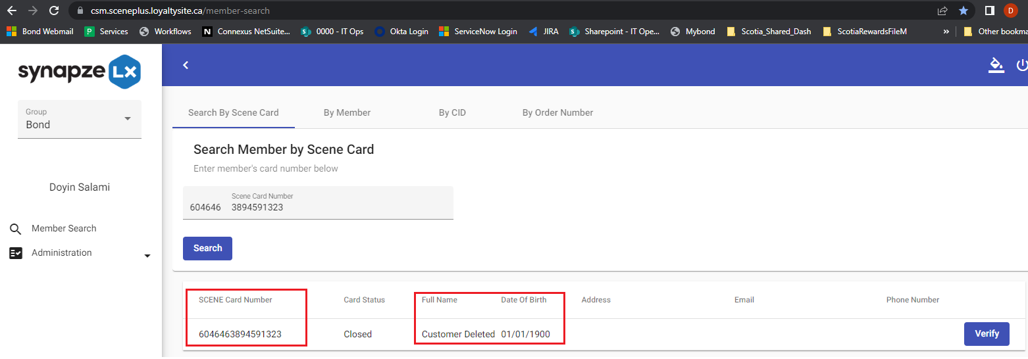

When the 'verify' button is clicked, we should receive a 'failure to fetch member information' message:
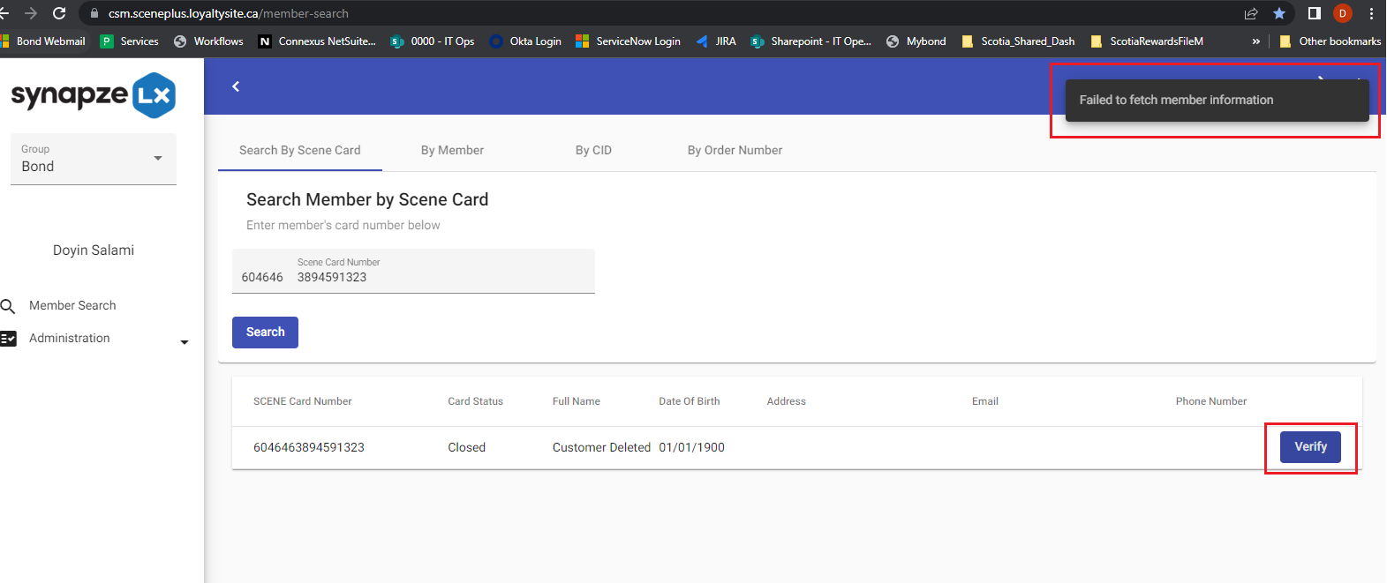

Phase 2 - Anonymization in Cosmos DB
The second step in dealing with the anonymization request is to delete the records in Cosmos DB by setting the time to leave value (TTL) to at least a day which is equivalent to 86400 seconds.

  - Activate the "CloudGrp_PIM_ScenePlus_DocumentDBAccountContributor" in Azure Privileged Identity Management to have write access to Cosmos DB, once approved (you should get an email once it is approved or you may follow up with Mustafa for escalation), then we can proceed with the next step below.

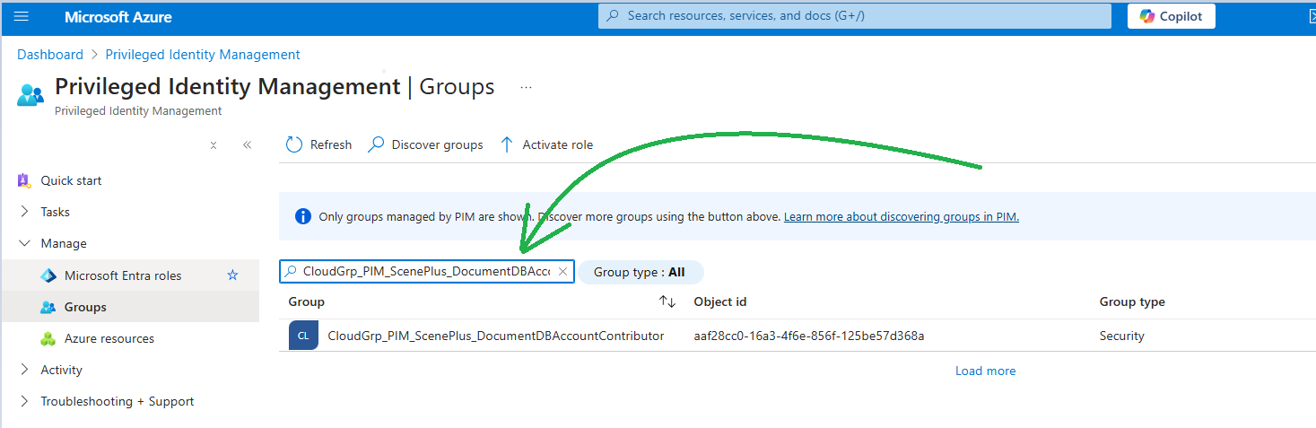

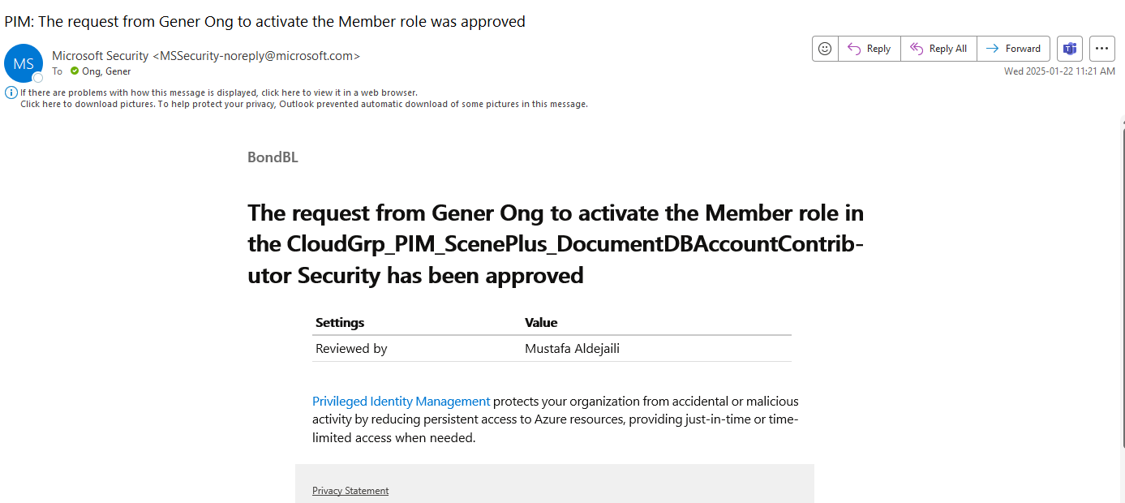

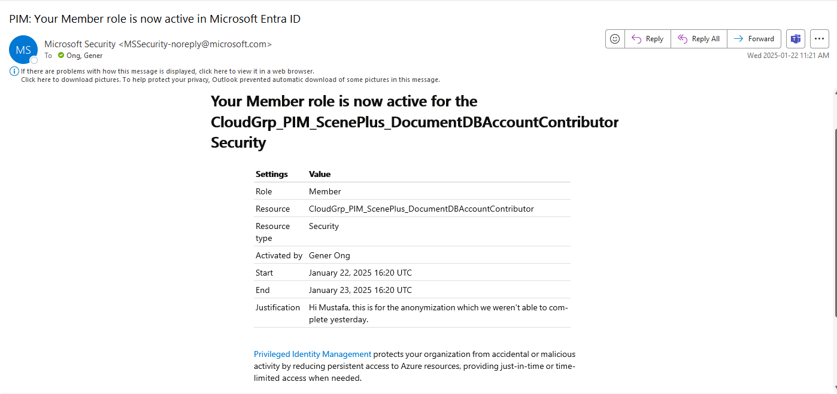

  - Once approved, and the access is provided, we need to log in to Azure Cosmos DB.
Azure Cosmos DB account name : sceneplus-prod-synapze-cosmosdb-p
URL: https://portal.azure.com/#@BondBL.onmicrosoft.com/resource/subscriptions/673c956d-04d2-4742-8975-8637efbaa329/resourceGroups/BNDAZ_SCENEPLUS_PROD_PRIMARY/providers/Microsoft.DocumentDB/databaseAccounts/sceneplus-prod-synapze-cosmosdb-p/overview
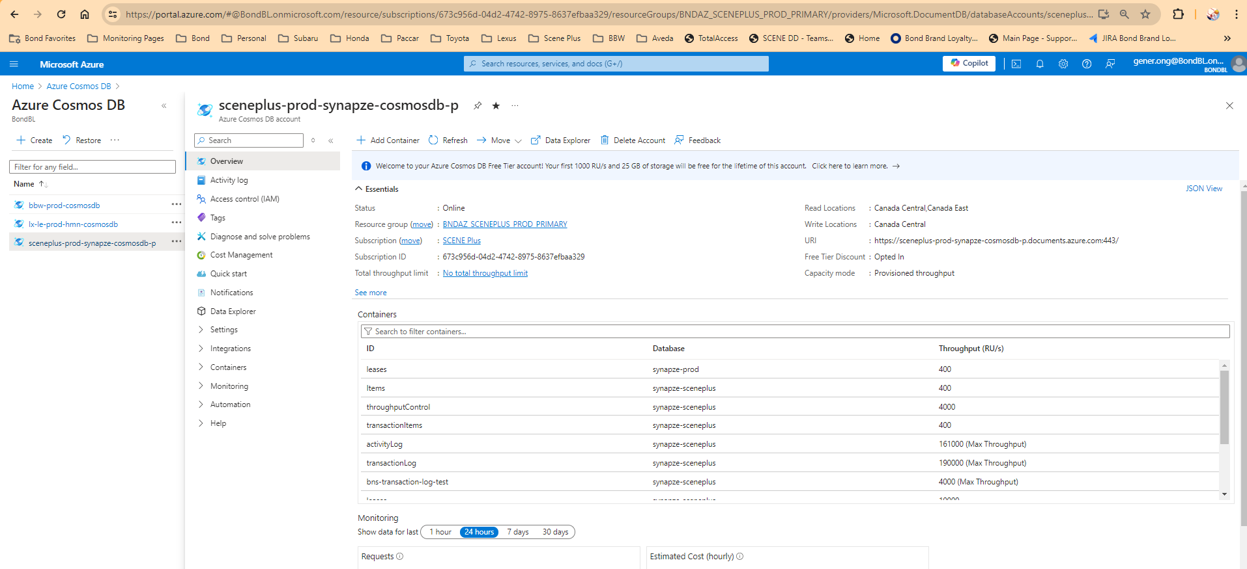

  - Click on the Data Explorer, then expand the database "synapze-sceneplus", expand the activitylog container, click on the Items and click the Edit Filter button.
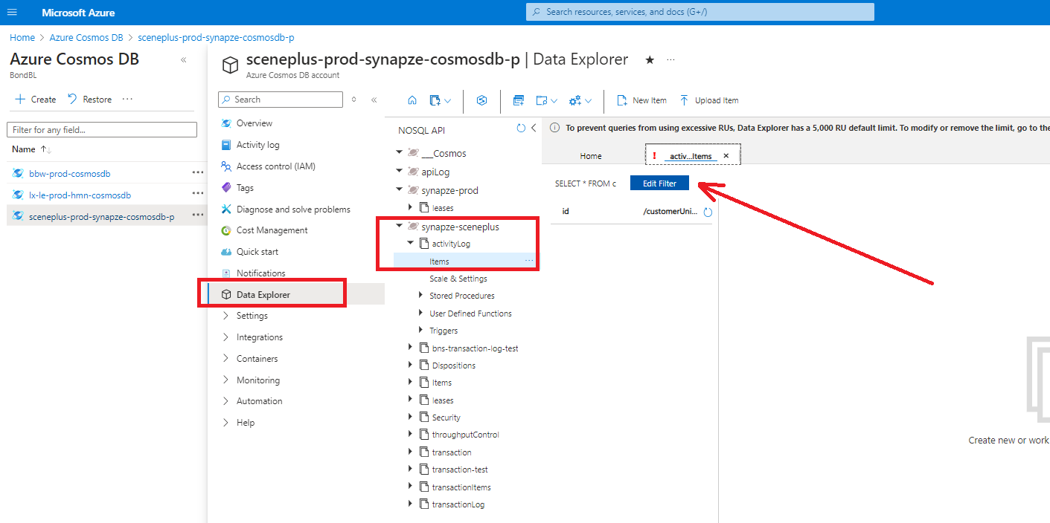

  - Add a where clause like in the sample stated below. And then click on the Apply Filter button.
It is important that the Customer Unique ID should be in lower case.
where c.customerUniqueId = {Lowercase Customer GUID}
e.i.: where c.customerUniqueId = '9d404568-e5e3-4181-8b14-db14971b86d9'

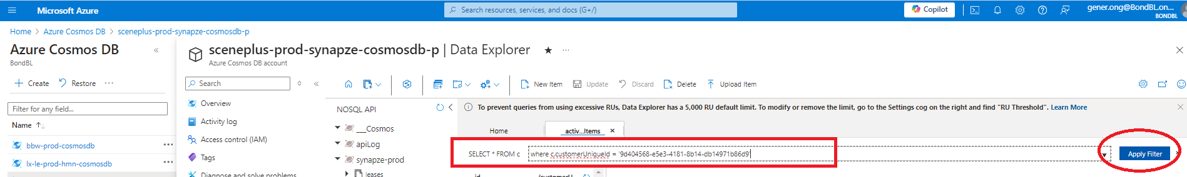

  - The records will be displayed if there is a match with the customer unique ID.
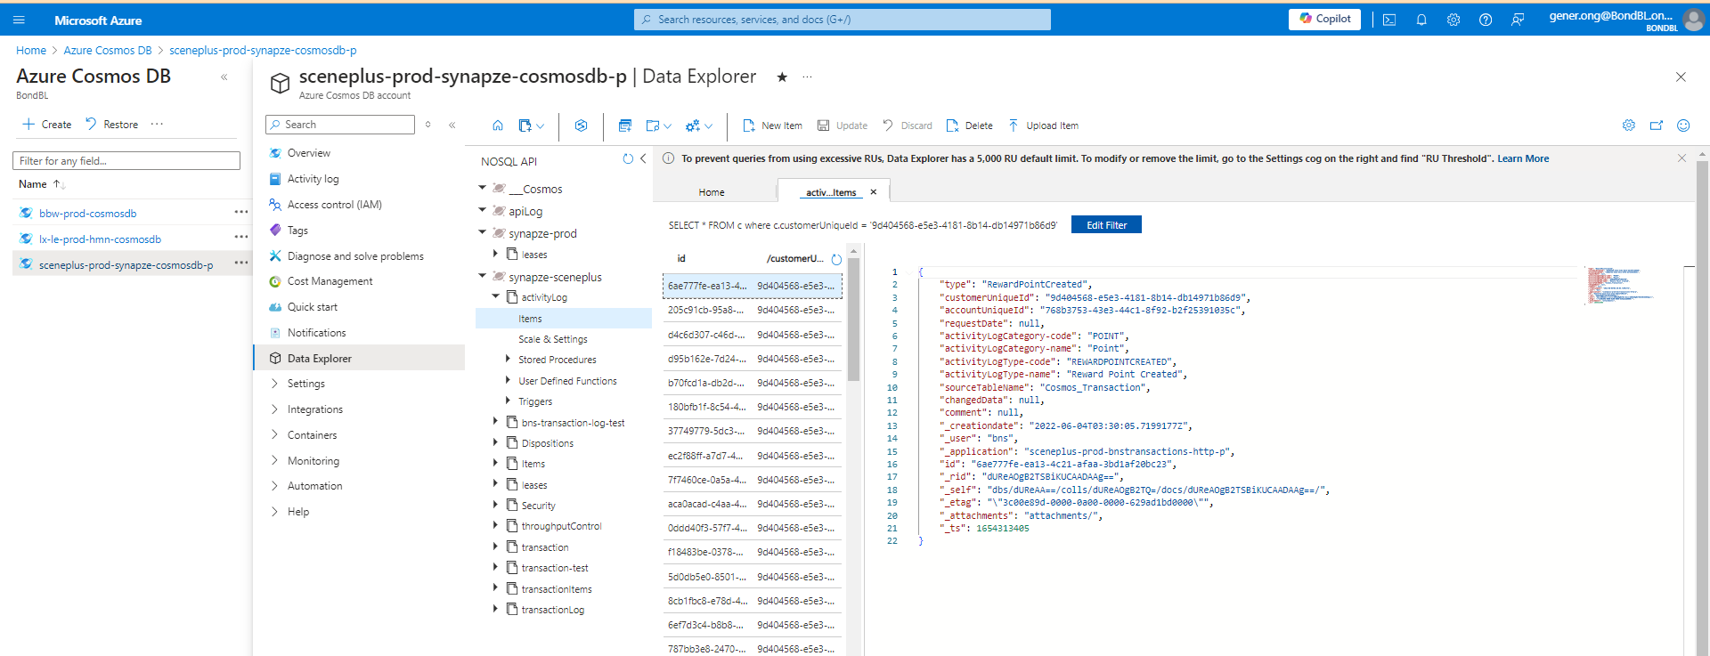

  - Once you click on the first available record, you will see details on the right side of the screen. We need to add the ttl value at the last line of each record and then click the Update button to save.
The value should be "ttl": 86400
Note : Once you click the update button, the ttl value might move to a different line and that should not be an issue. Please do not forget to add the comma before you add the ttl value.
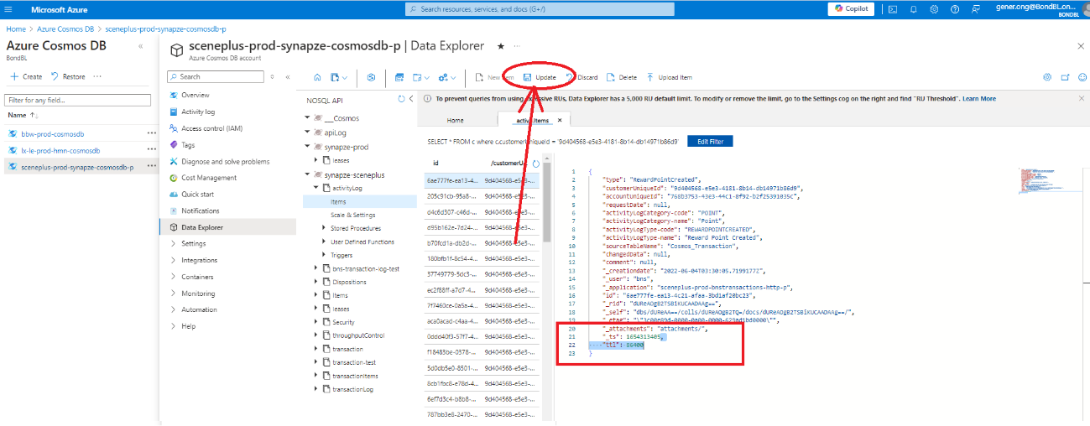
  - Do the same to other records. There might be more records, if that is the case, you can click the load more button at the bottom of the list.
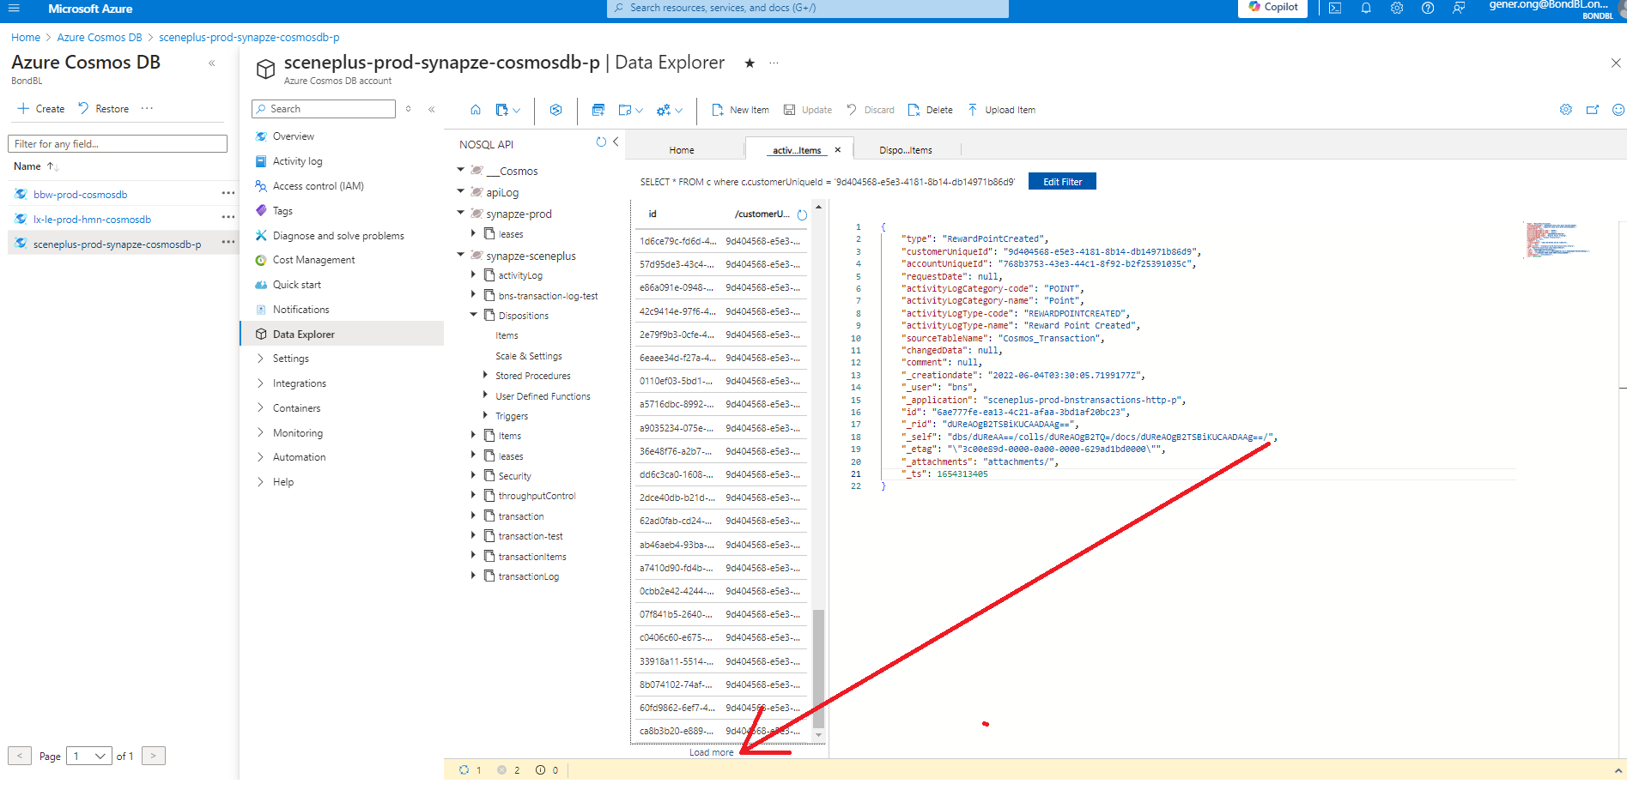

  - Once done with activityLog container, we will do the same thing with Dispositions and transaction container.
  - Below are the syntax or values that we need to add after clicking the Edit Filter button.
Dispositions:
WHERE c.pkey = 'memberdispositions' AND c.harmony_customer_unique_id = {Lowercase Customer GUID}
e.i.: WHERE c.pkey = 'memberdispositions' AND c.harmony_customer_unique_id = '9d404568-e5e3-4181-8b14-db14971b86d9'

transaction:
WHERE c.type = 'order' AND c.customerUniqueId = {Lowercase Customer GUID}
e.i.: WHERE c.type = 'order' AND c.customerUniqueId = '9d404568-e5e3-4181-8b14-db14971b86d9'

Important Note: Don not forget to click the Update button to save every time you add the ttl value, otherwise those changes will not take effect.
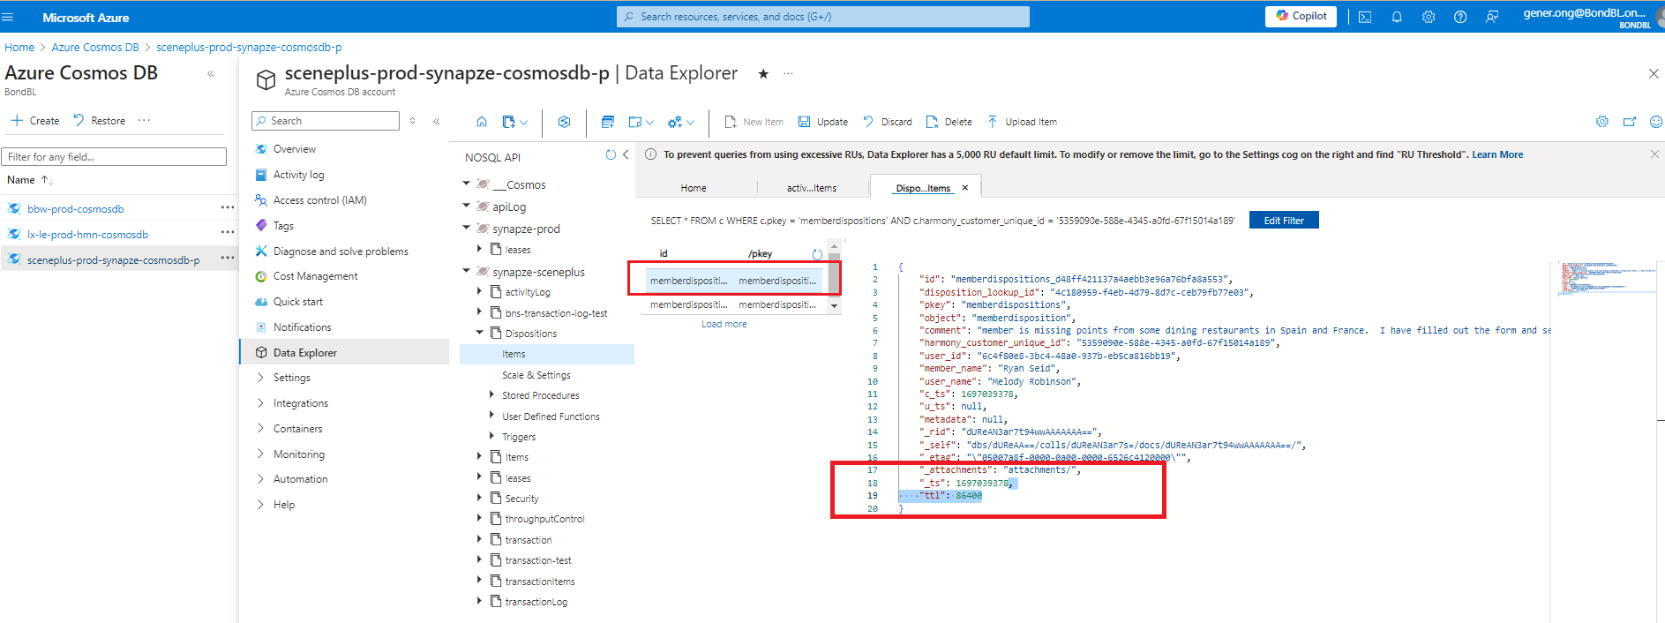

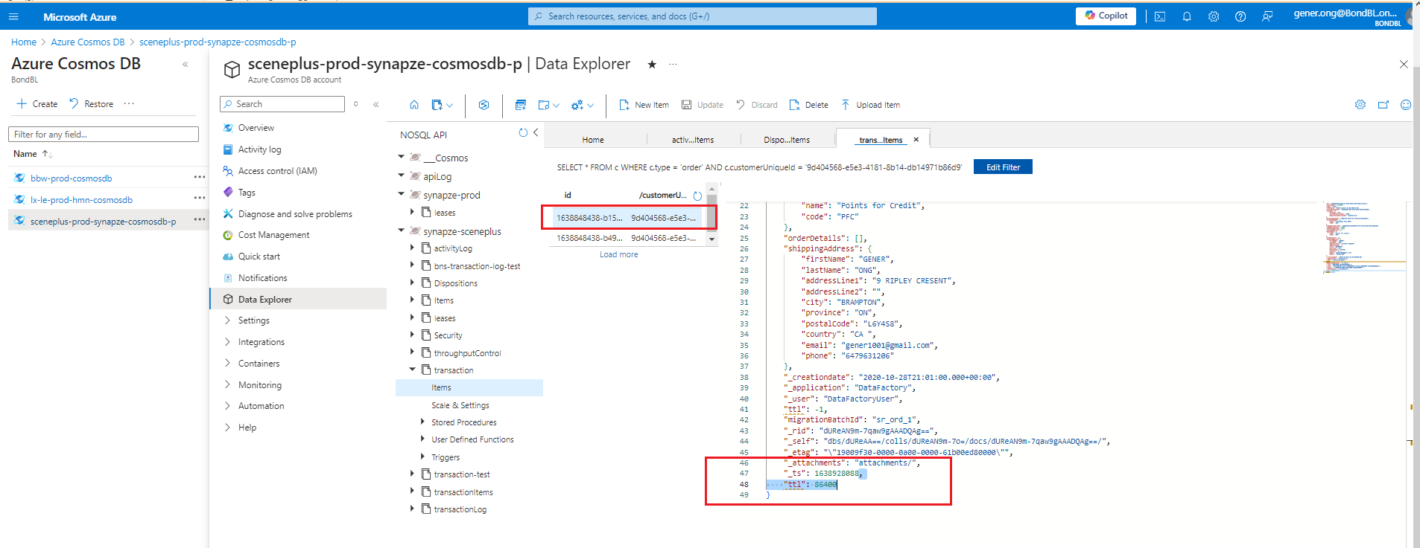

Phase 3 - Anonymization in Datalake (databricks)

This part of the anonymization will be performed in two different instances, one in sceneplus-prod-databricks-p and another one in sceneplus-prod-adb

Link to the notebook that we need to use for this anonymization
- sceneplus-prod-adb
PII-Data-Update-cdc-db-synapze-db - Databricks

Note : this is the old one in sceneplus-prod-databricks-p workspace, just keeping it here for reference
PII-Data-Update-cdc-db-synapze-db - Databricks (azuredatabricks.net)

Note that in step 11, we are not updating cdc_db.communication_emailrequest table.

- sceneplus-prod-adb
https://adb-489372236014778.18.azuredatabricks.net/editor/notebooks/2884172203392786?o=489372236014778#command/2884172203392787

Note: if you are doing this, make sure that you inform the data engineering team (analytics team) in teams' chat "Anonymization in Datalake (need to inform this team)"

For the script in 10th tile: we don't usually delete the record since it doesn't contain any PII data (confirm with Nikhil from DE)
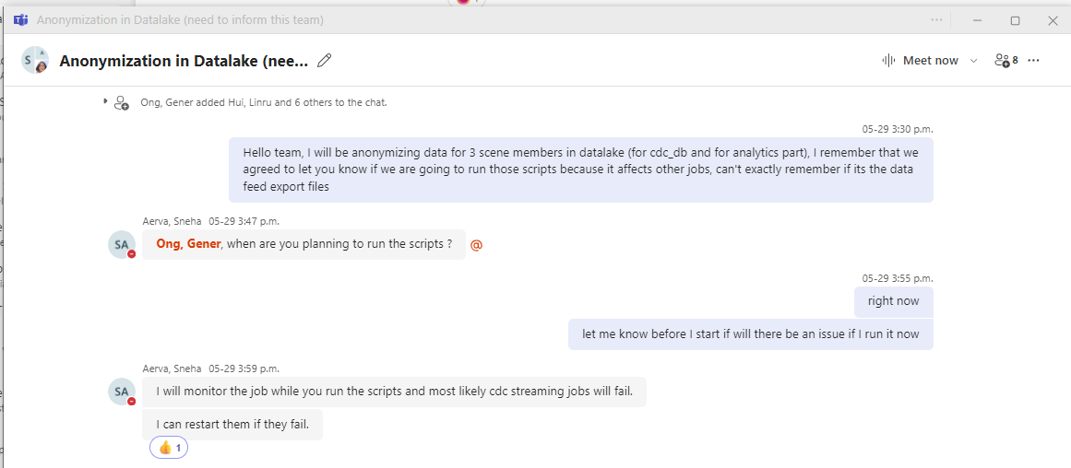

The job "harmony_cdc_stream-core_customer" and/or "harmony_cdc_stream-core_customer_address" is expected to fail when you run the anonymization in datalake.
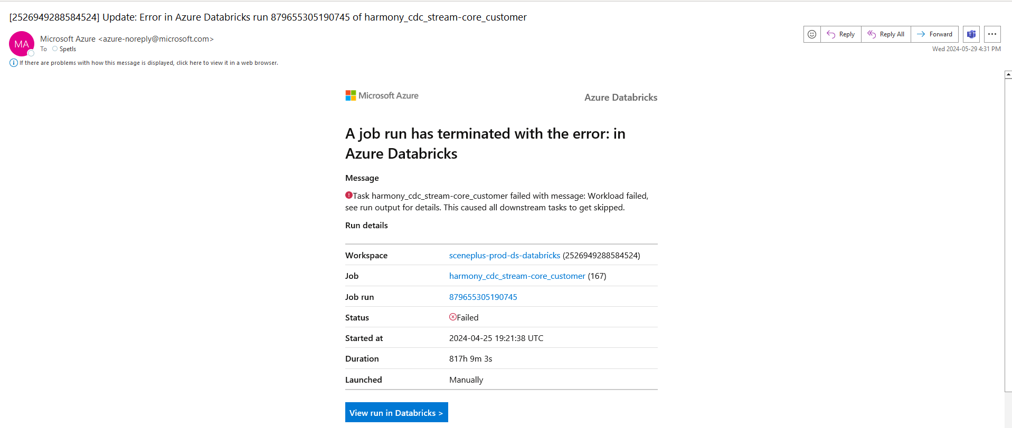

Do the anonymization first in sceneplus-prod-databricks-p
- Open the script and on the widgets, you specify the AccountID and CustomerID

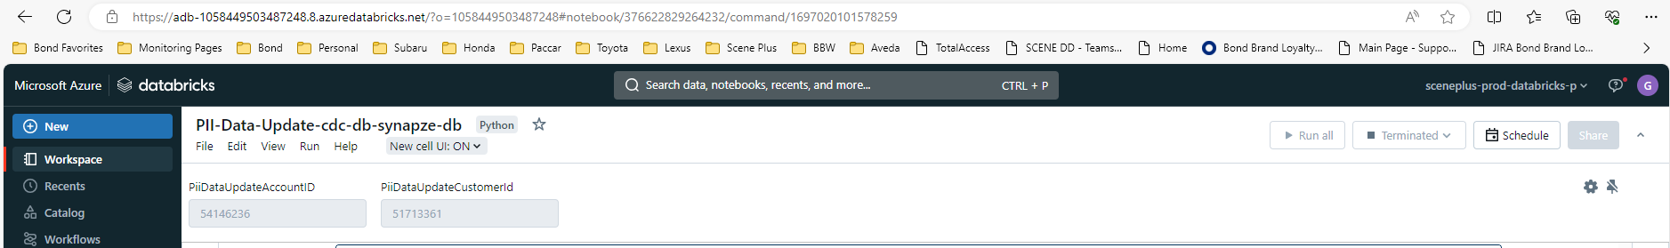

- If you need to identify those 2 information (AccountID and CustomerID), you can use the script in tile 13 on the same notebook
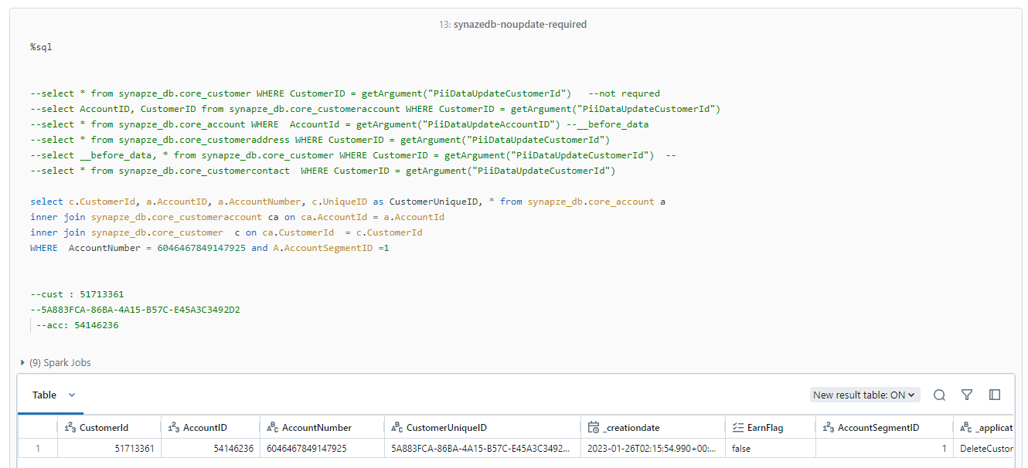
- Once you specify the AccountID and CustomerID, you can start running the tile one at a time.
- If PII data are being returned after you run the select script, you need to comment out the select statement and uncomment the update part, then rerun it to anonymize the PII data.
- There are 7 tiles to run, there is no need to run the update part of the script if there are no PII data seen after running the select statement.
- The same step is needed to follow for anonymization on sceneplus-prod-ds-databricks but we only need to populate the widget for the CustomerID.
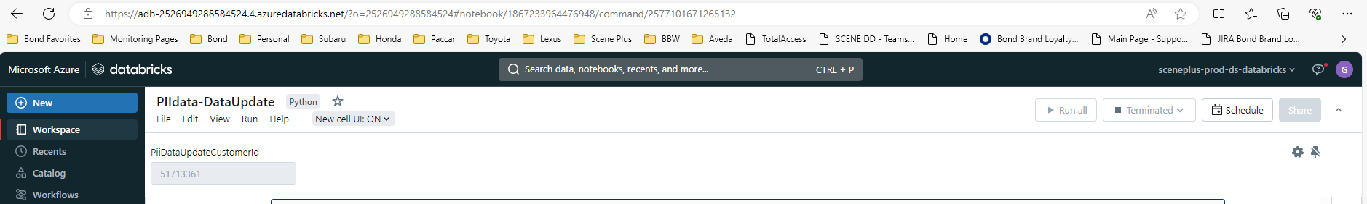

Phase 4 - Anonymization - PII Raw DB DATA Update
NB: This is step 4 and final data anonymization step - Step 1-3 must be completed before the execution of this step.

NOTE: This process is to be run as the last step (of the data anonymization) after all processes for PII data anonymization has been completed; i.e. SQL Update, Cosmos, Databricks (Datalake aka cdc db) secondary tables.

AIM of this process: Removes old date records from raw db.

The latest & optimized Raw DB script to be download, provided on 06/05/2024:
<<PII-RAWDBData-Delete-OldRecords-UpdatecsomosData-Optimize2 (1).py>>

Relevant cluster to run this process on - per time: sceneplus-prod-cluster

Link to the relevant notebook: https://adb-489372236014778.18.azuredatabricks.net/editor/notebooks/3381060858339415?o=489372236014778#command/3381060858339416

Note: this is the URL to the notebook in the old workspace https://adb-1058449503487248.8.azuredatabricks.net/?o=1058449503487248#notebook/1993123013804475/command/1993123013804476

Suggested time of the day to run due to execution time: From 9AM, to maximize day time execution.

Guideline for now: Execute this process for only one user account at a time; more than one user at a time may result in unexpected spark driver closer and memory usage errors - even on the sceneplus-high-powered-cluster.

Step 1: Initialization of relevant variables holding the account number (same as Scene card number, put the card number in the widget) to be anonymized:

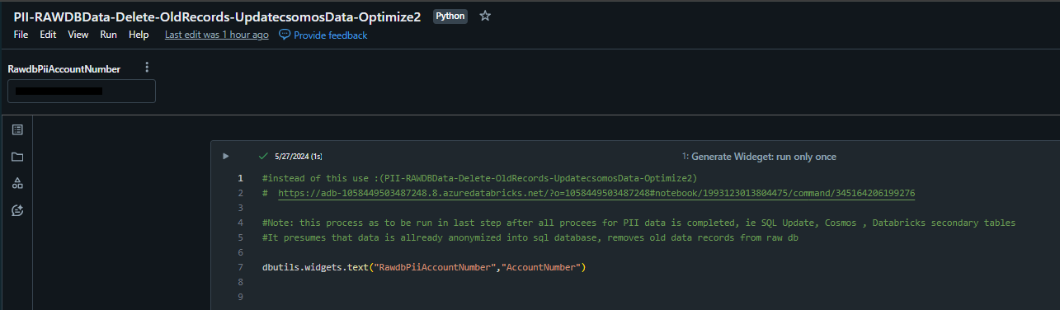

Step 2: Shows the account to confirm the correct account number:
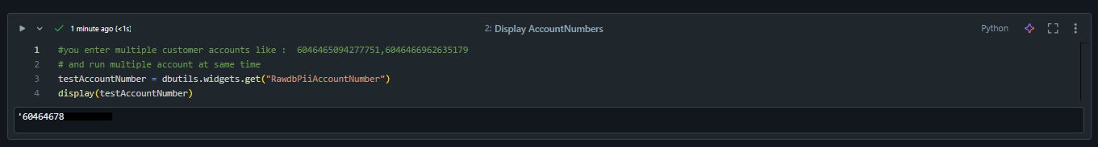

Step 3: Initialization of libraries:
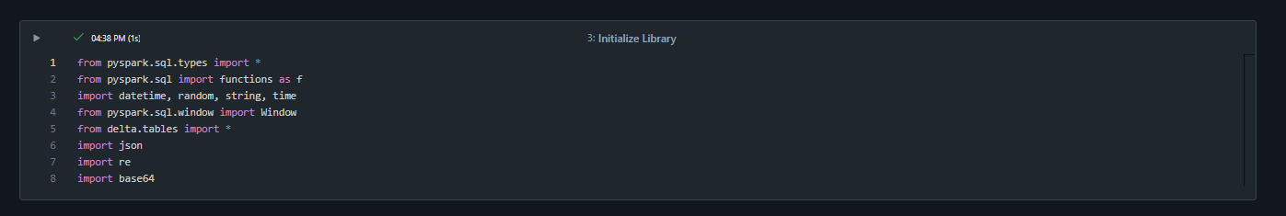

Step 4: Confirmation that the relevant account details is deleted in SQL.
The result of this cell execution should read: FirstName = Customer, lastName = Deleted

Ideal result if two user accounts are provided as values:

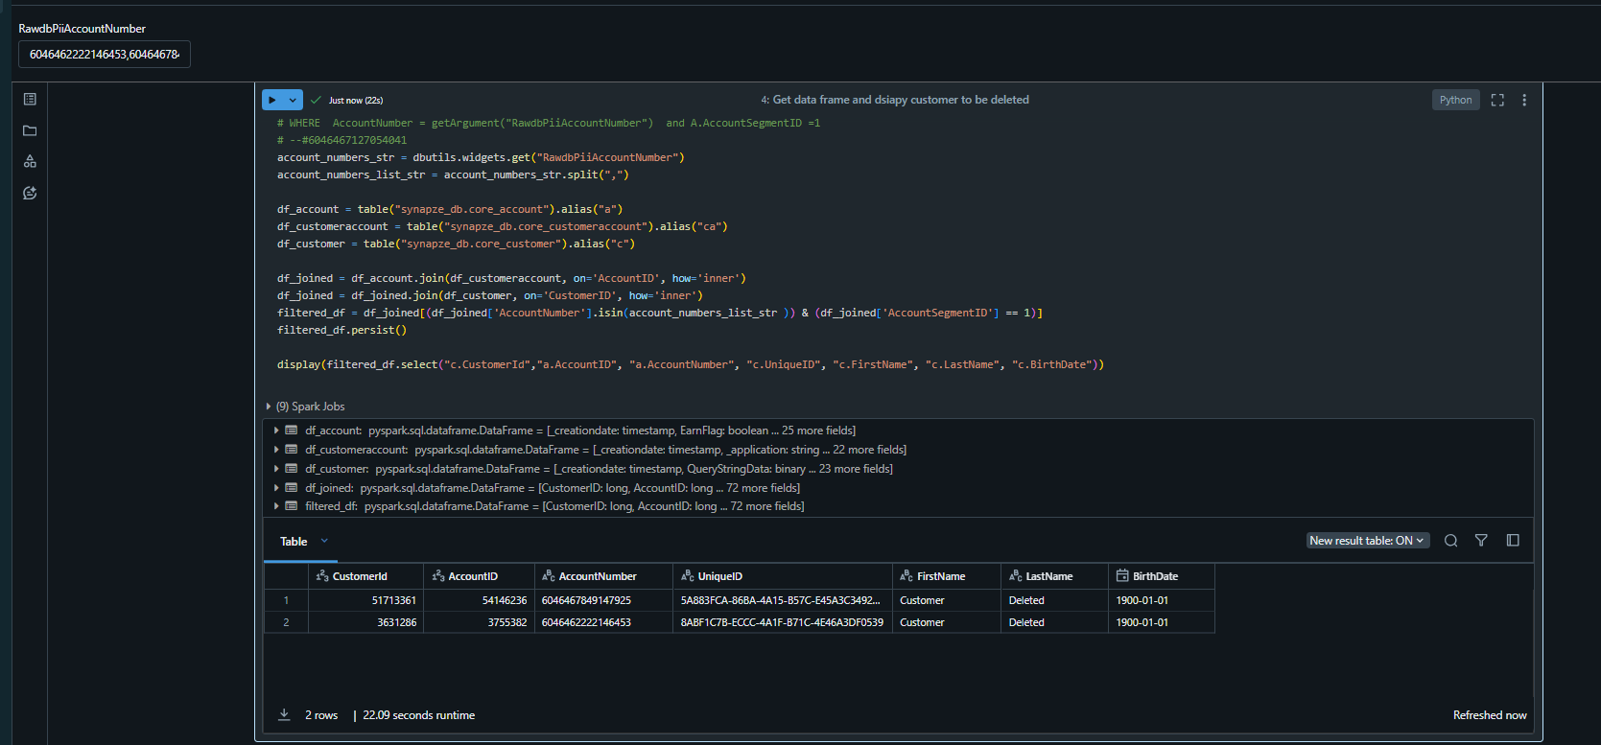

Step 5: Retrieve the relevant IDs
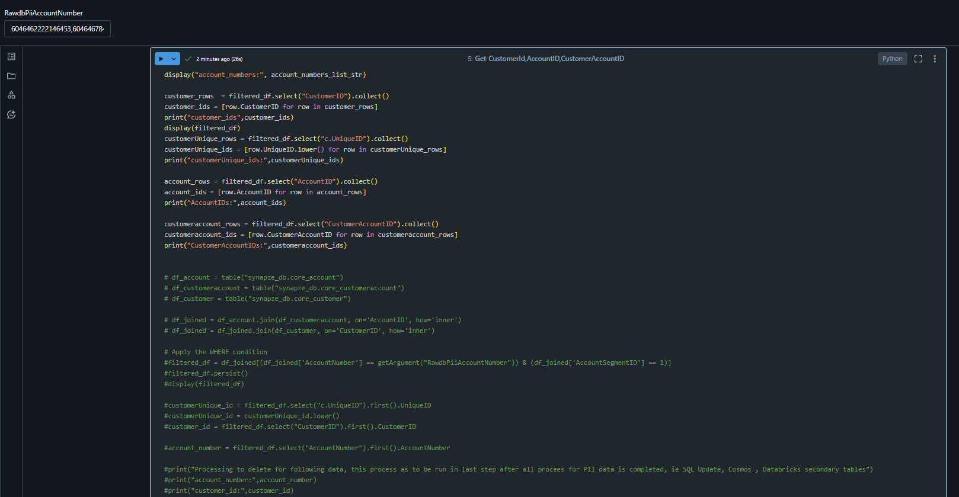

Ideal result:
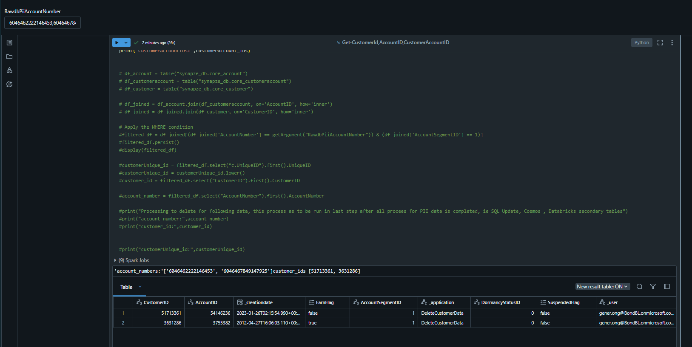

Step 6: Can be skipped, as it's not significant to the update; and was only included for verification purposes.

Step 7: 1. program_eventhub_data: Delete Old Version of data using CustomerID
- The execution of this step could take approximately 7 hours as confirmed in the run on 05/27/2024.
- The step update includes 7 tables; 7 tables (4 Core tables + 3 communication tables) + 1 bns table + activityLog + transaction = 10 tables in total.
- Below is a sample of a successful execution for step 7 (All 7 table updates in one step) - the screenshot is a general overview, the result details will differ per the relevant account being anonymized:
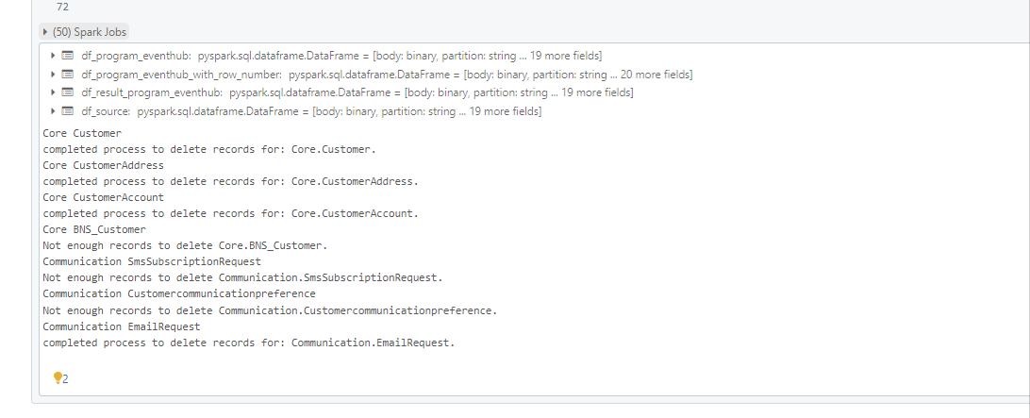

NB: As of 06/03/2024 step 7 has been broken into two steps:

Part 1: Step 7: 1. program_eventhub_data: Delete Old Version of data using CustomerID: Core: 4 tables (Highlighted)
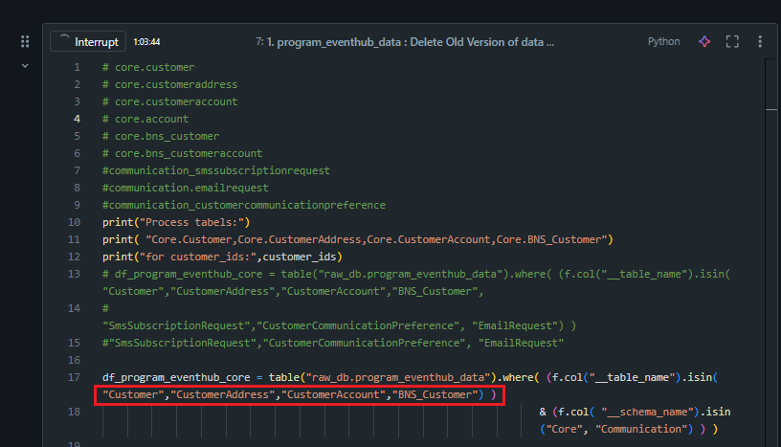

Sample of a typical result for Step 7 - Part 1 (Core tables update) execution: Successful/lack of enough data to update:



Step 8: To release cache from the previous run. As of 06/05/2024, the Team has confirmed this step can be skipped, hence the commenting out of the command:

Part 2 of step 7 - Step 9: 1. ( 2) : program_eventhub_data : Delete Old Version of data using CustomerID for Communication : 3 tables:


Sample of a typical result for Step 7 - Part 2 (Communication tables update) execution: Successful/lack of enough data to update:
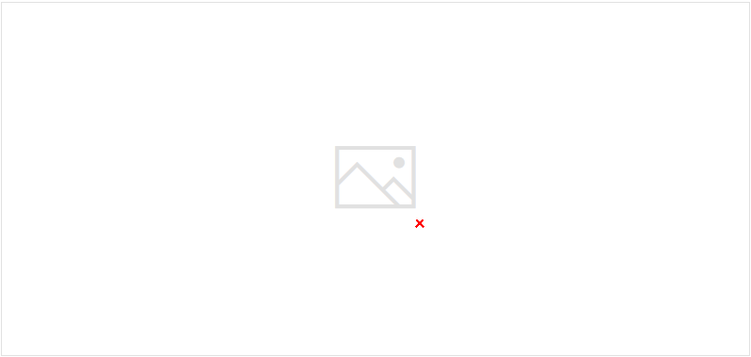

NB: If step 7 fails with for e.g. (or fails with any other error) the error message: The spark driver has stopped unexpectedly and is restarting. Your notebook will be automatically reattached.
If you immediately re-run step 7 - part 1 again for instance, you'll likely get an undefined variable/instance error

Resolution: Re-run steps 3, 4 & 5 again - in that order, then re-run the failed step, and continue execution from there - if required.

The same resolution applies, if the job was left running the previous day and a step encountered an issue.

Step 10: To update the BNS Table:

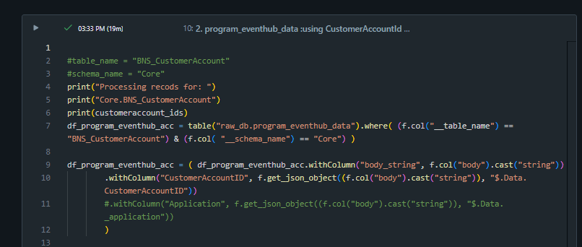

Sample of a typical result for Step 10 execution: Successful/lack of enough data to update:
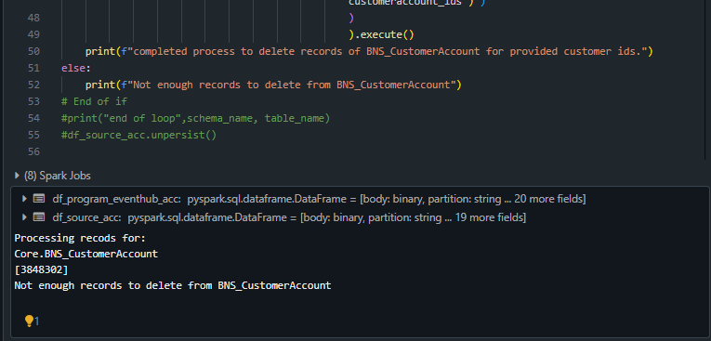

Step 11: Can be skipped, as it's not relevant to the overall update:

Step 12: Activity Log
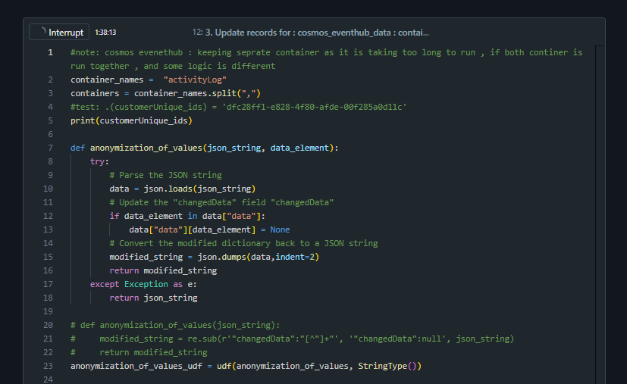

Sample of a typical result for Step 12 execution: Successful/lack of enough data to update:
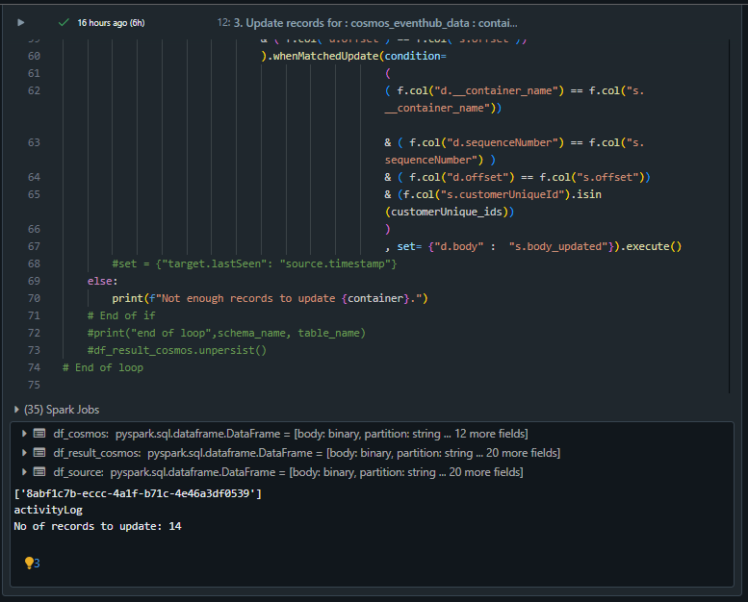

Step 13: Transaction update - this will be relevant if the member has orders:
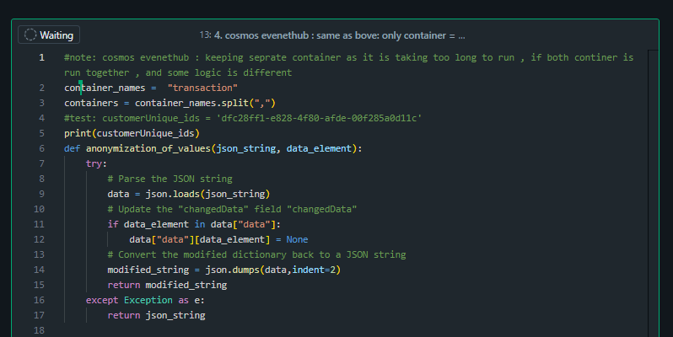

Sample of a typical result for Step 13 execution: Successful/lack of enough data to update:
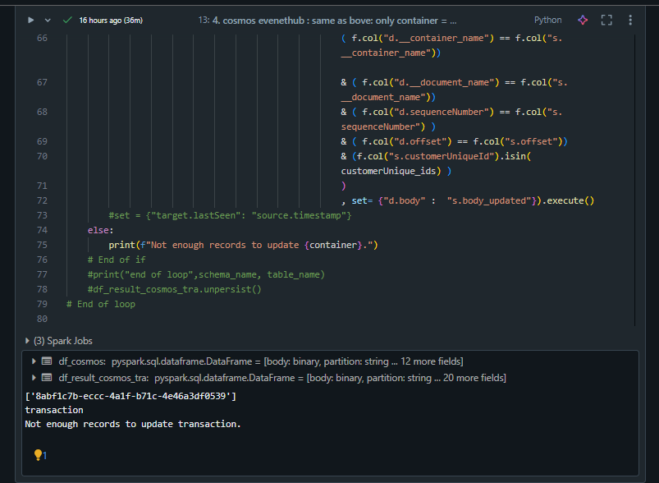

STEP 14: Release cache
This final command, unlike the other un-persist command encountered in step 8, must be executed, for obvious reasons.

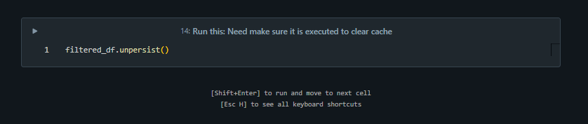

Ideal output:

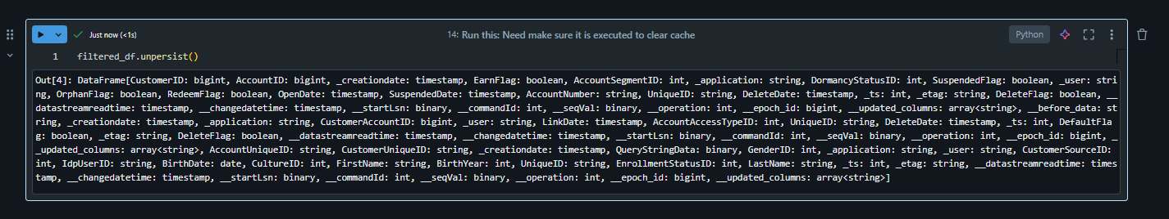

NB:
Should there be a need to continue running this process for an account from the previous day's run, and the next step to be ran is step 14, if one proceeds to run step 14 and encounters the below error:
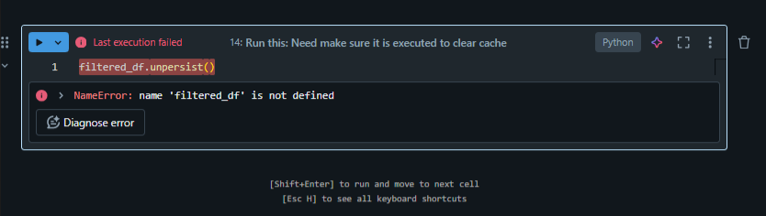

Please follow the direction in 'Resolution' as outlined above step 10. Once complete, one should have the ideal output as shown for step 14.

High Level:
- Click the link below to open the notebook. Then, clone it by adding the Zoho ticket number at the end of the notebook name.
https://adb-489372236014778.18.azuredatabricks.net/editor/notebooks/847880568554930?o=489372236014778#command/847880568554931
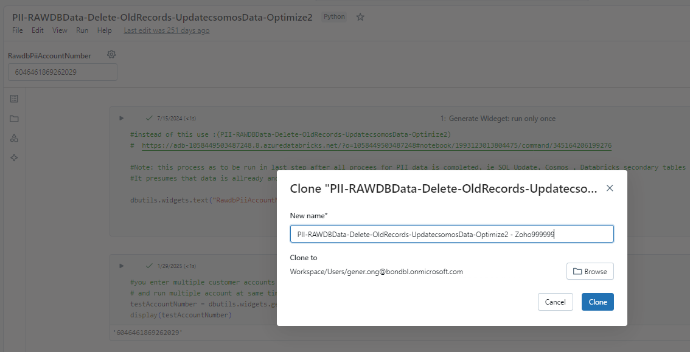

- Put in the card number in the widget, then follow the one shown in the screenshot to select the cluster
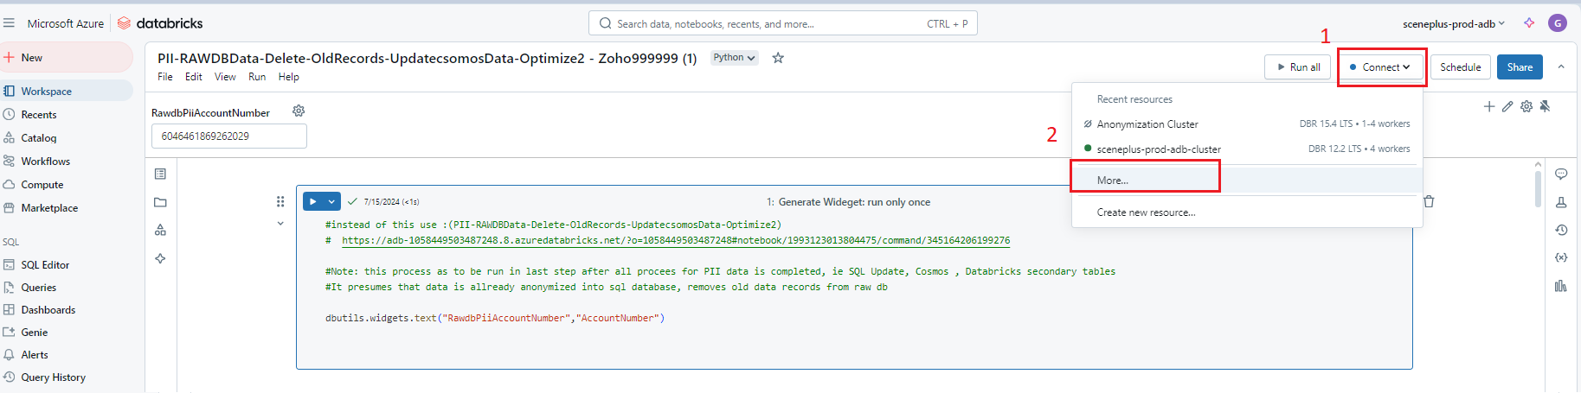

- A window will pop out, choose the "Anonymization Cluster" and click Attach.
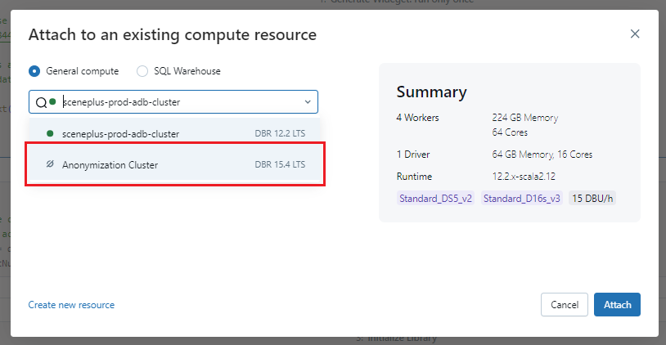

- Click the "Run All" button once it is connected to "Anonymization Cluster" (if the indicator shows color green)
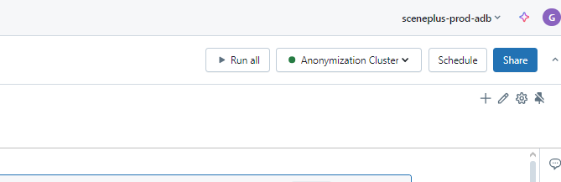

- Most important, once done, please terminate the cluster although it will be terminated after 15 minutes of inactivity.

